Q . What is SDLC? Explain each phase of SDLC ?

ans -

SDLC -The Software Development Life Cycle (SDLC) refers to a methodology with clearly defined processes for creating high-quality software

* The Software Development Life Cycle (SDLC) refers to a methodology with clearly defined processes for creating high-quality software. in detail, the SDLC methodology focuses on the following phases of software development:

1. **Requirement Gathering -**
2. **Analysis**
3. 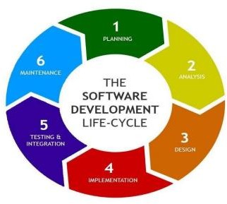**Designing**
4. **Implementation**
5. **Testing**
6. **Maintenance**

1 > Requirement gathering - Requirement gathering is the most important and necessary stage in SDLC. Project organizer set up a meeting with the client to gather all the data like what the customer wants to build,

Before creating a product, a core understanding or knowledge of the product is very necessary.

**Example** - A client wants to have an application which concerns money transactions.

-In this method, the requirement has to be precise like what kind of operations will be done, how it will be done,

-in which currency it will be done

2> Analysis -During this software development lifecycle phase, the specialists meticulously collect precise requirements from the customer to present a solution fine- tuned to their needs. Any unclarities must be elucidated in this stage only.

3> Designing - In the design phase, software engineers analyze requirements and identify the best solutions to create the software. For example, they may consider integrating pre-existing modules, make technology choices, and identify development tools. They will look at how to best integrate the new software into any existing IT infrastructure the organization may have.

4>Implementation - In the implementation phase, the development team codes the product. They analyze the requirements to identify smaller coding tasks they can do daily to achieve the final result.

5>Testing - The development team combines automation and manual testing to check the software for bugs. Ǫuality analysis includes testing the software for errors and checking if it meets customer requirements. Because many teams immediately test the code they write, the testing phase often runs parallel to the development phase.

6> Maintenance - In the maintenance phase, among other tasks, the team fixes bugs, resolves customer issues, and manages software changes. In addition, the team monitors overall system performance, security, and user experience to identify new ways to improve the existing software.